|  |  |
| --- | --- |
| **Assignment Case** |  |
| COMP6064 | COMP6590 | T0243  Geographical Information System |
| **Computer Science** | **O213-COMP6590-MZ02-01** |
| ***Valid on*** *Odd Semester Year 2019/2020* | **Revision 00** |

1. Seluruh mahasiswa tidak diperkenankan untuk:

*All students are not allowed to:*

* + - Melihat sebagian atau seluruh jawaban mahasiswa lain,

*Seeing a part or the whole answer from other student*

* + - Menyadur sebagian maupun seluruh jawaban dari buku,

*Adapted a part or the whole answer from the book*

* + - Mendownload sebagian maupun seluruh jawaban dari internet,

*Downloading a part or the whole answer from the internet,*

* + - Mengerjakan soal yang tidak sesuai dengan tema yang ada di soal,

*Working with another theme which is not in accordance with the existing theme in the matter of the case,*

* + - Melakukan tindakan kecurangan lainnya,

*Committing other dishonest actions,*

* + - Secara sengaja maupun tidak sengaja melakukan segala tindakan kelalaian yang menyebabkan hasil karyanya berhasil dicontek oleh orang lain / kelompok lain.

*Accidentally or intentionally conduct any failure action that cause the results of the project was copied by someone else / other groups.*

1. Jika mahasiswa terbukti melakukan tindakan seperti yang dijelaskan butir 1 di atas, maka **nilai mahasiswa** yang melakukan kecurangan (menyontek maupun dicontek) akan di – **NOL** – kan.

*If the student is proved to the actions described in point 1 above, the score of the student which committed dishonest acts (cheating or being cheated) will be “Zero”*

1. Perhatikan jadwal pengumpulan jawaban, segala jenis pengumpulan jawaban di luar jadwal tidak dilayani.

*Pay attention to the submission schedule, all kinds of submission outside the schedule will not be accepted*

1. Persentase penilaiaan untuk matakuliah ini adalah sebagai berikut:

*Marking percentage for this subject is described as follows:*

|  |  |  |
| --- | --- | --- |
| **Tugas Mandiri**  *Assignment* | **Proyek**  *Project* | **UAP**  *Final Exam* |
| 40% | - | 60% |

1. Software yang digunakan pada matakuliah ini adalah sebagai berikut:

*Software will be used in this subject are described as follows:*

|  |
| --- |
| **Software**  *Software* |
| ArcGIS Desktop 10.8 |

## Ekstensi file yang harus disertakan dalam pengumpulan tugas mandiri dan proyek untuk matakuliah ini adalah sebagai berikut:

*File extensions should be included in assignment and project collection for this subject are described as follows:*

|  |  |
| --- | --- |
| **Tugas Mandiri**  *Assignment* | **UAP**  *Final Exam* |
| GDB, LOCK, SPX, ATX, TIMESTAMPS, CAL, GDBTABLE, MXD, EXP, GDBTABLX, FREELIST, PDF, GDB, GDBINDEXES | GDB, LOCK, SPX, ATX, TIMESTAMPS, CAL, GDBTABLE, MXD, EXP, GDBTABLX, FREELIST, PDF, GDB, GDBINDEXES |

## Soal

*Case*

**Kedonganan**

**Kedonganan** is a popular district located in Bali. You are asked to create the **geographical features** and **data** for **Kedonganan** by designating its **parking area**, **roads**, and **places of interest** using the **ArcMap** **application**. **Base map** and **Coordinate System** already provided by Geographical Designer.

* First, view the assigned area by following the steps below:
  1. Open **ArcMap** and create a new **Geodatabase**.
  2. Open the **.png** grid map file that has been given using the **ArcMap**.

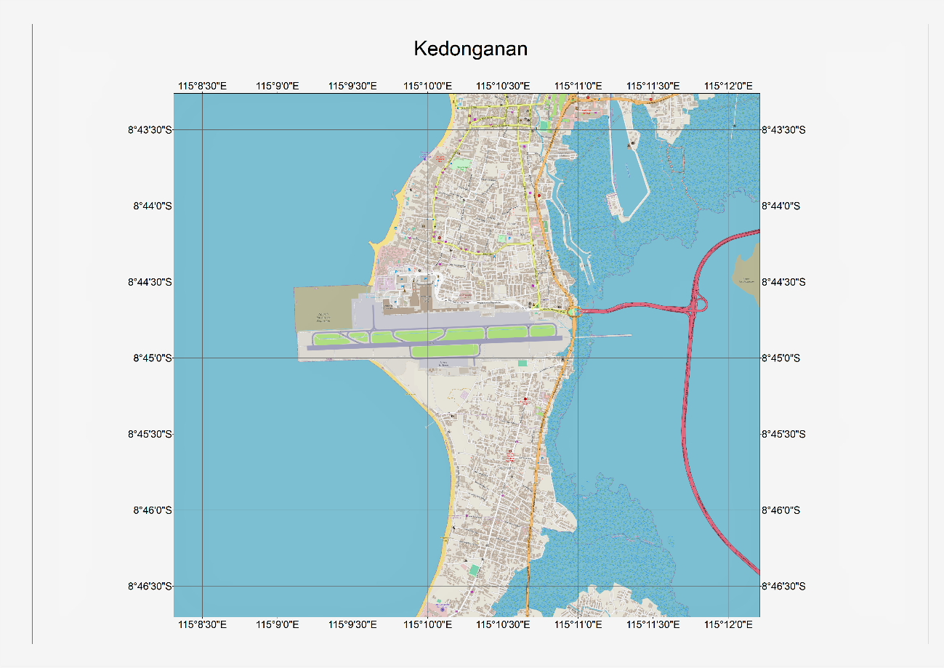

**Figure 1. Grid Map**

* 1. **Georeferenced** the **grid image** based on the coordinate and **rectify the image**.
  2. Open the **.png** section map file that has been given using the **ArcMap**.

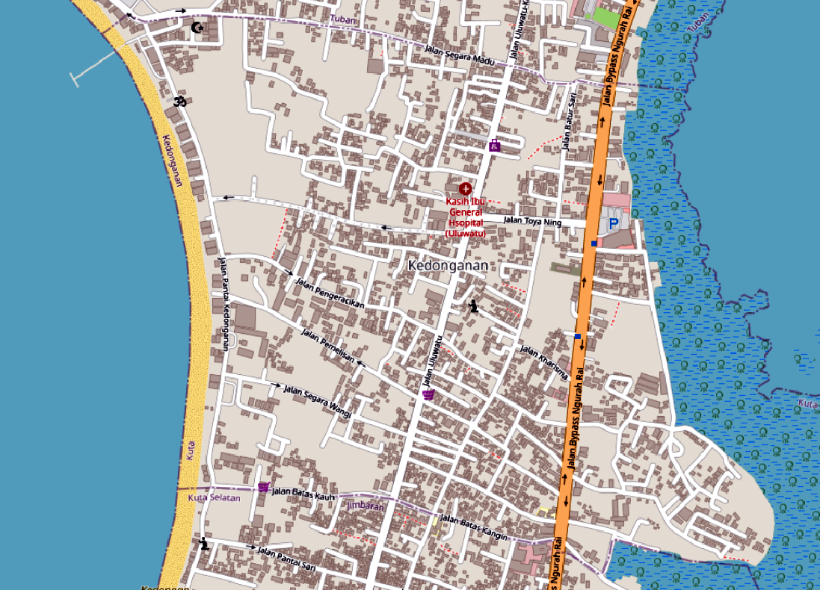

**Figure 2. Section Map**

* 1. **Georeferenced** the **section map** based on **the grid map** and **rectify the image**.

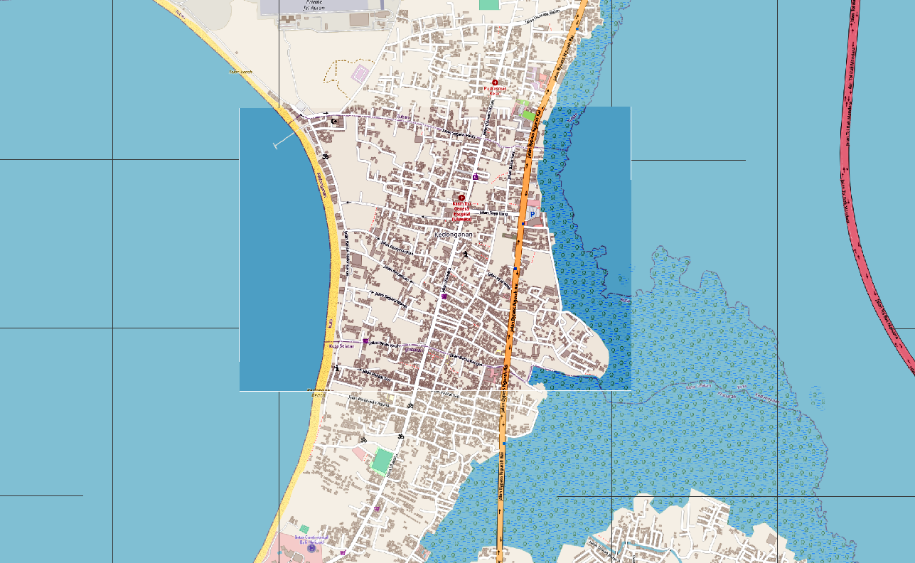

**Figure 3. Image after Rectify**

* Create a **geodatabase** with the following feature classes:
  + - **Polygon** **feature** that shows the **Parking Area** with the following attributes:

|  |  |  |  |
| --- | --- | --- | --- |
| **Field Name** | **Data Type** | **Length** | **Notes** |
| Name | Text / String | 50 | Input manually.  **Example**: ‘**Toya Parking Area**’. |
| TotalCar | Long | - | Taken from the **round down** value of ‘**SHAPE_Area’** **divided** by **10**.  (*Shape Area :* **‘4881.878274’,**  *Total Car :* **‘488’**). |

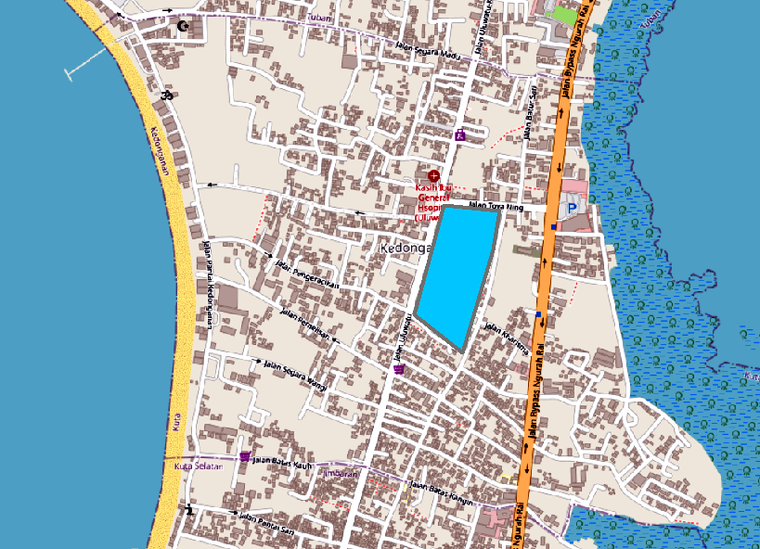

**Figure 4. Example polygon feature**

* + - **Line** **feature** that shows at **least 10 roads** in the map with the following attributes:

|  |  |  |  |
| --- | --- | --- | --- |
| **Field Name** | **Data Type** | **Length** | **Notes** |
| Name | Text / String | 50 | Input manually.  **Example**: ‘**Bakung Sari**’. |
| ID | Text / String | 20 | Started with **‘J’** and the **last 1** **character** of **‘Name’** and **‘Object Id’,** in **all uppercase** format.  (*Name*: ‘**Jl. Segara Madu**’, *Object ID*: ‘**15**’  *Id*: ‘**JU15**’). |
| Price | Long | - | Taken from the **‘SHAPE_Length’** and **multiply** by **9000**. |

***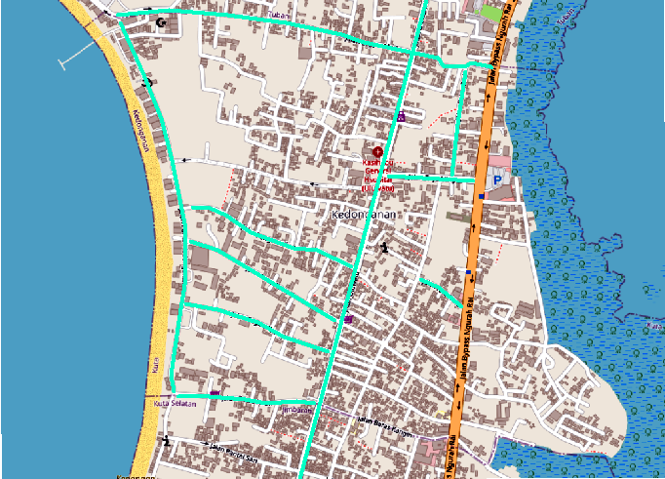*Figure 3. Example line feature**

* + - **Point feature** that shows **at least 15 points** **of interest** in the map with the following attributes:

|  |  |  |  |
| --- | --- | --- | --- |
| **Field Name** | **Data Type** | **Length** | **Notes** |
| Name | Text / String | 50 | Input manually.  **Example**: ‘**Pura Uluwatu’** |
| Type | Text/ String | 20 | Input manually. Must between ‘**Worship Place**’, ‘**Market**’, or ‘**Restaurant**’ |
| ID | Text / String | 20 | Taken from the **first character** of ‘**Type**’and ‘**Object Id**’, in **uppercase**.  (*Type*: ‘**Worship Place**’, *Object Id*: ‘**15**’,  *ID*: ‘**W15**’). |
| BuildingPrice | Long | - | Taken from **‘Name’** length **multiplicity** by **10000000**. |

Then **change the points of interest symbol** using **symbology** categorized based on “**Type**” field.

|  |  |
| --- | --- |
| **Type** | **Symbol** |
| Market | : Square 1, blue, size 20 |
| Restaurant | : Star 1, yellow, size 25 |
| Worship Place | : Star 1, green, size 25 |

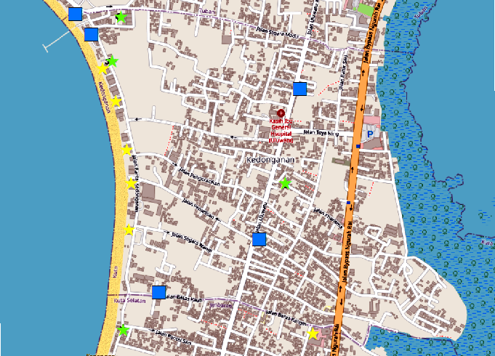

**Figure 4. Example point feature**

* Collect the **.mxd**, **.gdb** and **.cal** files in a zip and make sure that collected files **can be opened**.
* This is an example of a completed map:

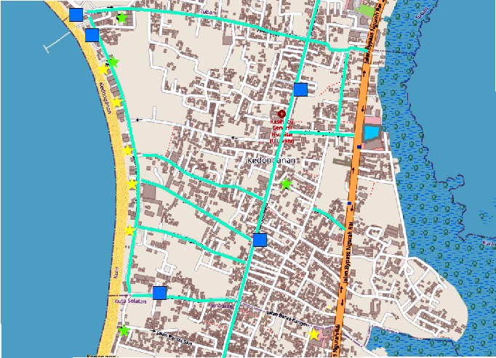

**Figure 6. Example completed map**

**Notes**:

* All **formulas** in the “**field calculator**” must be saved into a .cal files.
* All **control points** must be saved into a .txt files.
* All **rectify images** must be saved into a .png files.
* Pictures shown above are just an example. Your result may be different.
* Make sure the **RMS error** is below 1 for the georeferenced **grid map** and **RMS error** is below 5 for the georeferenced **section map**
* The georeferenced **grid map** and **section map** must have at least 4 **control points**

**Files to be collected:**

* + Control Point (.txt)
  + Map Exchange Document (.mxd)
  + Geodatabase (.gdb)
  + Field Calculator (.cal)
  + Image after Rectify (.png)